

Assignment No: 4

Date: 12th September 2026

Title: Unipolar and Polar NRZ and RZ Line Codes using Python and Simulink

Name: Joe Blogs ???

Course: Bachelor of Engineering in Electronic Engineering

Subject: Digital Communications and Transmission

Lecturer: Ben Graham

Summary: To generate and investigate various line codes (NRZ, RZ) using python and simulink

OBJECTIVES:
After the completion of this experiment, students will have good knowledge about the four line codes:
- Unipolar NRZ
- Polar NRZ
- Unipolar RZ
- Polar RZ

EQUIPMENT REQUIRED:
Computer with access to Kaggle.

THEORY:
Unipolar NRZ The signal stays at +V for the entire bit interval for a binary one and 0V for the total bit time for a binary zero.
Polar NRZ The signal stays at +V for the entire bit interval for a binary one and -V for the total bit time for a binary zero.
Unipolar RZ The signal stays at +V for 50% and 0V for the other 50% of the bit interval for a binary one and 0V for the total bit time for a binary zero.
Polar RZ The signal stays at +V for 50% and 0V for the other 50% of the bit interval for a binary one and -V for 50% and 0V for the other 50% of the bit time for a binary zero.

Total Marks : 100

All work must be completed and submitted inside THIS Document

Part 1- Unipolar NRZ - (Marks:20)S

- Register an account on Kaggle using your student email address.

- Once you log onto your Kaggle account, on the left hand side, select the code icon.

- This will open a Kaggle notepad and allow us to write python based code to simulate line codes.

- The code in Figure 1 below allows us to create a simple NRZ waveform for a given binary code.

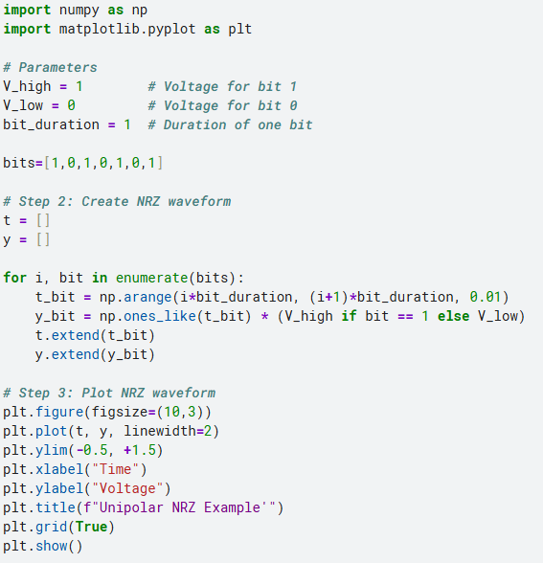
Figure 1 – Base NRZ code

Task 1: Base NRZ Implementation

Using the core setup logic for a standard binary line code simulation, execute a Python script to generate a basic Unipolar NRZ waveform.

Answer 1: Paste the waveform you have created here and comment on it.
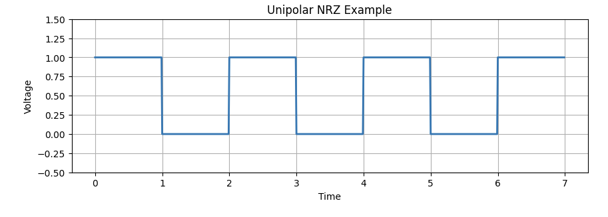
Se trata de una secuencia de 7-bits (1010101), que tiene como flanco de subida en 1 voltio y en reposo como 0 voltios. El tiempo esta determinado secuencias de 1 bit.
Se trata de una onda unipolar NRZ, lo cual quiere decir que solo usa un polo, el positive en este caso, y ademas no vuelve a 0 a menos que haya un flanco de bajada.

Task 2: Custom Sequence Generation (+5V)

Change the program to generate a +5 V Unipolar NRZ waveform for the 8-bits, 11010010.

Answer 2 : Paste the regenerated waveform you have created here and comment on it.
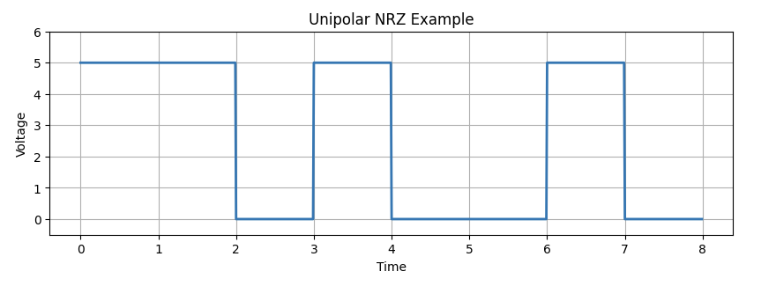
Se trata de una secuencia de 8 bits (11010010) en la que le flanco de subida se situa en +5V y el de bajada en 0V. El tiempo de igual forma que el ejercicio anterior se divide en intervalos de 1 bit. Y asi mismo se trata de una onda NRZ Unipolar

Task 3: Character Encoding Generation (+5V)

Change the program to generate a +3.3V Unipolar NRZ waveform for:ASCII for first letter of your name

Answer 3 : Paste the generated waveform you have created here and comment on it.
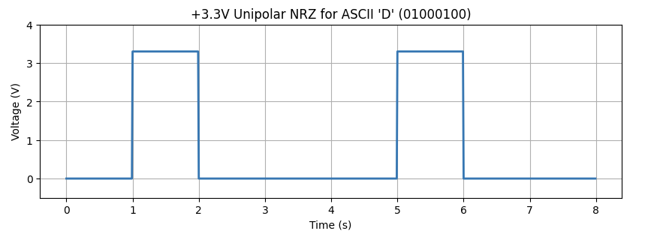
Esta onda se trata de una secuencia de 8 bits (01000100) que representa la primera letra de mi nombre, D, de David. Esta tiene un flanco de subida en 3.3V y de bajada en 0V. Se puede apreciar que este char necesita un flanco de subida en los bits 1 y 5.

Hint Code:
#char = 'B' # ASCII character to convert
# character to binary (8-bit)
#ascii_code = ord(char)
#binary_str = format(ascii_code, '08b')
#bits = [int(b) for b in binary_str]
Note: Google/AI will help with python functions/ideas.

Part 2 – Polar NRZ - (Marks:10)
Edit your existing code

Task 4: Character Encoding Generation (+/-12V)

Generate a ±12 V Polar NRZ line code for ASCII ‘#’.
_______________________________________________________________

Answer 4: Copy the code and waveform and paste here ensure waveform is labelled and has a corresponding title.

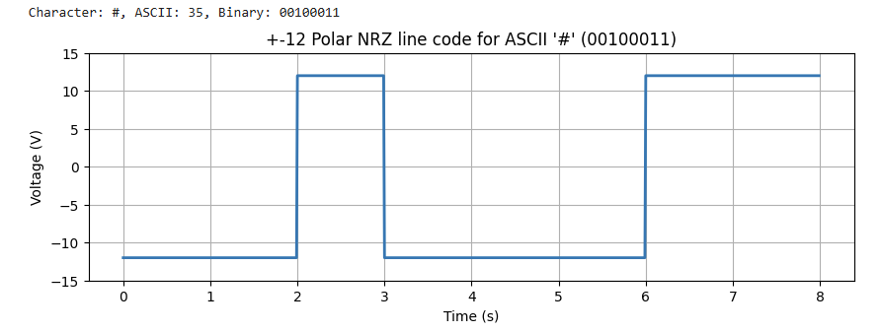
Se trata de la onda de una secuencia de 8 bits(00100011) con un flaco de subida en +12V y de bajada en -12V. Este tipo de senal se caracteriza por usar ambos polos para representar los flancos de subida y bajada, como se puede apreciar en este caso.

Part 3 – UniPolar RZ - (Marks:15)
Using the code below in Figure 2

Task 5: Character Encoding Generation

Generate a +3 V Unipolar RZ line code for 0xB3 hex.

Hint:

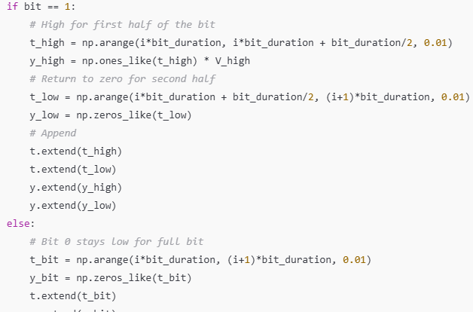

Figure 2 – Base RZ code

Answer 5: Copy the code with waveform and paste here ensure waveform is labelled and has a corresponding title.

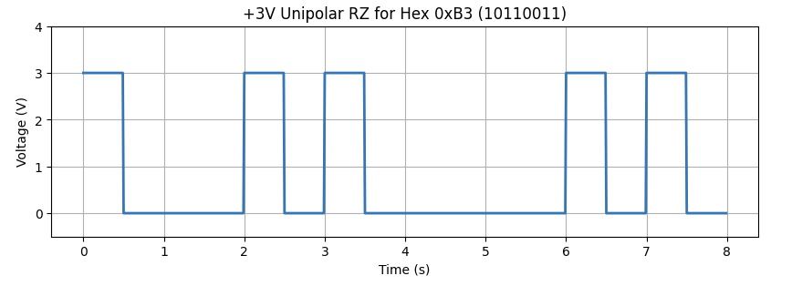
En esta onda de 8-bits(10110011) para representar 0xB3 podemos apreciar que tiene el flanco de subida en +3V y el de bajada en 0V ya que es unipolar. Ademas, es RZ por lo que a la mitad del flanco de subida, este Vuelve a 0.

Part 4 – Polar RZ - (Marks:15)
Edit your existing code to

Task 6: Character Encoding Generation

Generate a ±3 V Polar RZ line code.

Answer 6: Copy the code with waveform and paste here ensure waveform is labelled and has a corresponding title.
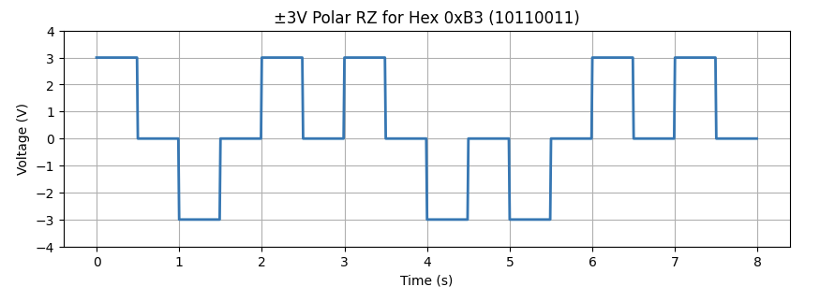

Part 5 – Simulink - (Marks:40)
Move now to Matlab on line (you should have an account from last year), open Simulink with Matlab.

Task 7: Unipolar NRZ

- Generate a +5 V Unipolar NRZ line code using the following blocks:

First place a binary signal source, the binary signal source will randomly outputting either a logic 0 or 1.
As Simulink basic is the only option available to us, obtaining a simple logic generator is more involved than it should be and requires the following 3 components

- Uniform Random Number
- Relational Operator
- Constant

The uniform random generator settings at Min = 0, Max = 1, Seed = 1 and sample time 0.5. The constant is setup to output a constant 0.5. The relational operator set to greater or equal (>=).

This will create a random logic output between 0 and 1.

Next create the 5V unipolar NRZ output. The signal will stay at the +5V for a binary 1 and 0V for a binary 0.

To achieve this an additional component is required

- Gain block (set to 5)

Set simulation time to 10 seconds, scope the output of the relational operator and the gain block to view the input logic and output unipolar NRZ.

Answer 7: Include Simulink circuit and waveforms here.
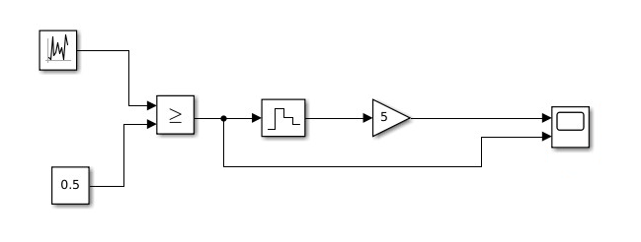
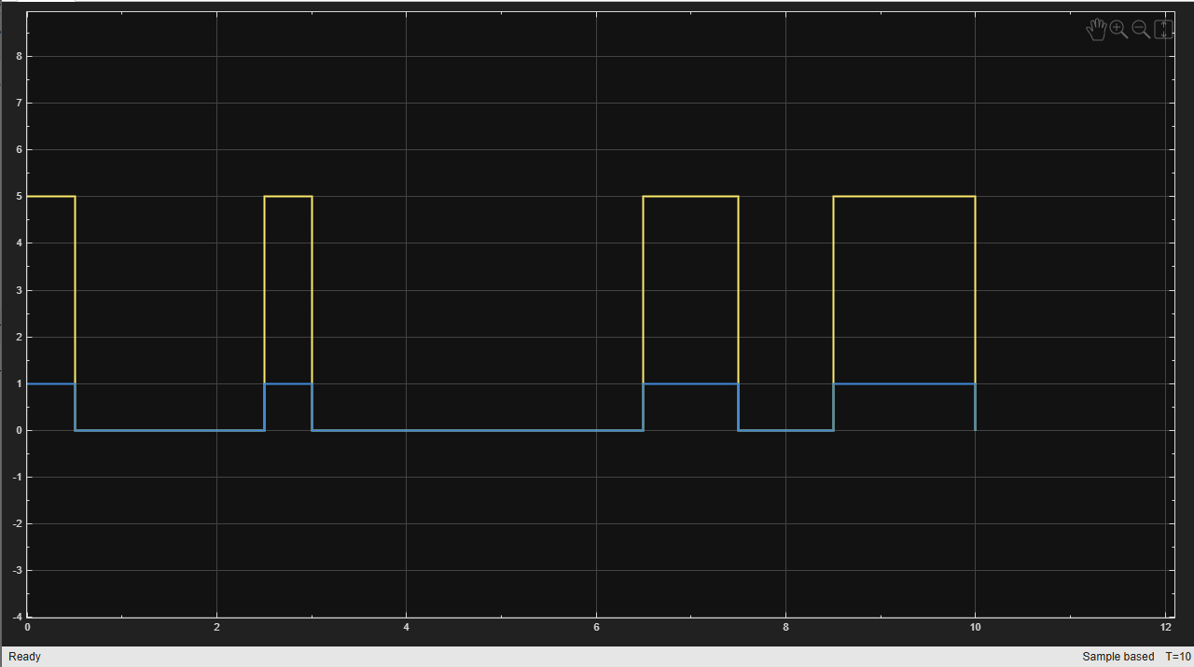

Figure 3 – Simulink NRZ unipolar

Task 8: Polar NRZ

- Generate a +5 V Polar NRZ line code:

Next create the 5V polar NRZ output. The signal will stay at the +5V for a binary 1 and -5V for a binary 0.

To achieve this 3 additional components are required

- Gain block set to 2
- Sum block
- Constant set to - 1

The logic output 0 or 1 needs to be amplified by 2, this output is this added to -1.
We get the +/- 5V output required

Bit 0 = (2 x 0) = 0 + (-1) = -1
Bit 1 = (2 x 1) = 2 + (-1) = -1

The output of this sum is then multiplied by 5, to obtain the +5V.

Answer 8: Include Simulink circuit and waveforms here.
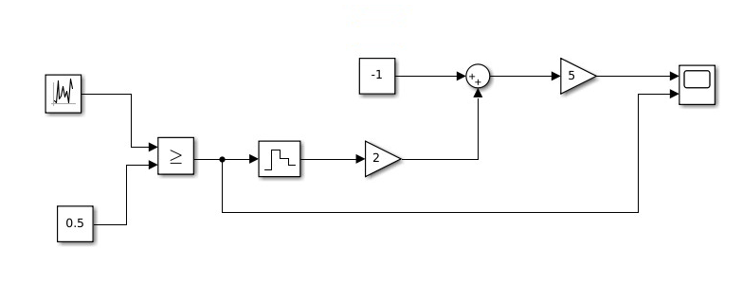
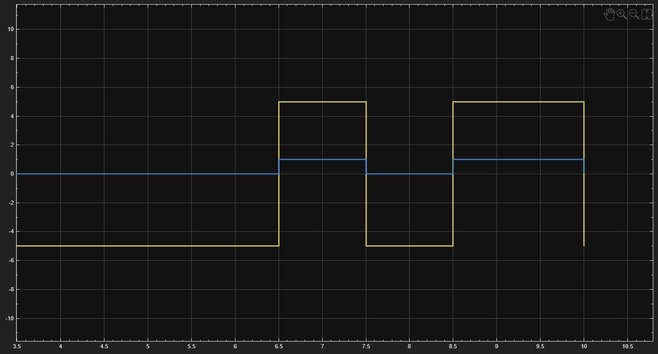

Task 9: Polar RZ

- Generate a +5 V Unipolar RZ line code using the following blocks:

Once again a logic signal is needed for all of the following sections, this randomly outputting either a 0 or 1. We will use the same circuit as before for this section to create the 0 and 1 bits logic input.

In additional for the RZ the waveform needs to return to 0 for the last half of the positive. This can be achieved by using

- Pulse Generator
- Product

The pulse generator is set to the same frequency as the random generator (0.5 seconds). Duty cycle is set to 50%.

The output of the pulse generator and the logic signal (zero order hold) can then be fed to product. Output will be RZ compliant, gain, etc will be required to achieve the correct voltages.

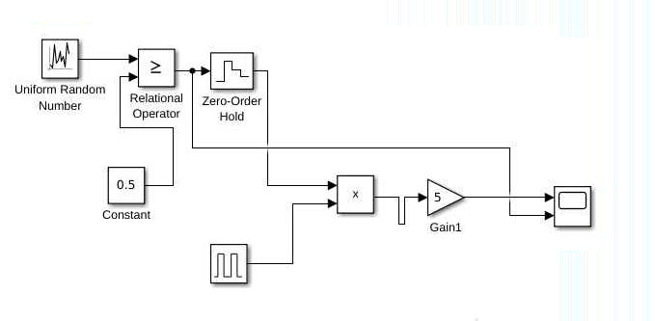
Figure 4 – Simulink RZ unipolar

Answer 9: Include Simulink circuit and waveforms in here
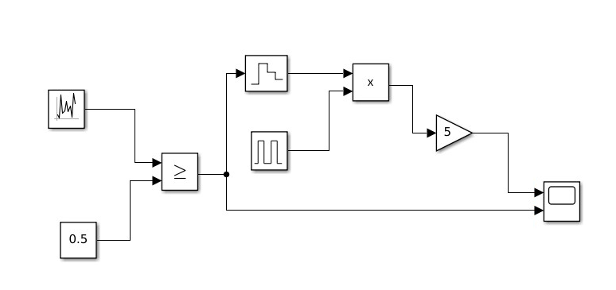
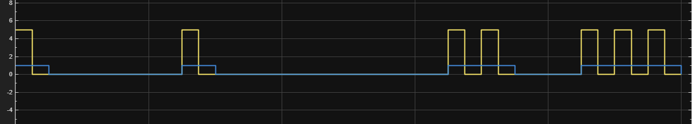

Task 10: Polar RZ

- Generate a +3 V Polar RZ line code:

Repeat for +3V polar RZ line code

Answer 10: Include Simulink circuit and waveforms here

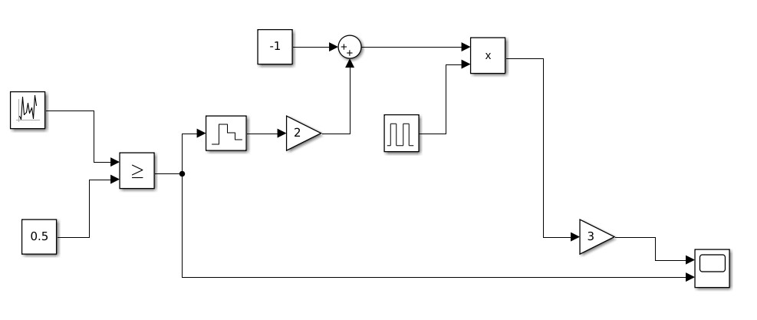
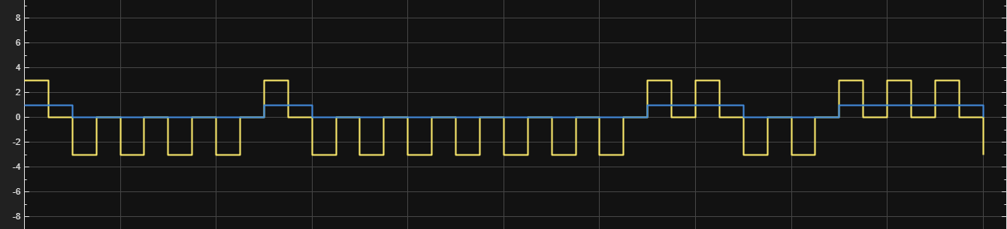

Note: Ensure all questions are answered and included in the worksheet

